 | 26.10.4 Editors - Properties Editor - Particle Properties Tab - Velocity panel
Table of content
Velocity Panel 1
Normal 1
Tangent 1
Tangent Phase 1
Object Aligned 1
Object Velocity 1
Randomize 1

Velocity Panel

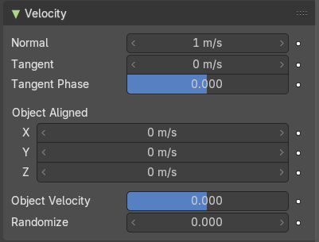
Velocity settings.

Normal
Let the surface normal give the particle a starting velocity.

Tangent
Let the surface tangent give the particle a starting velocity.

Tangent Phase
Rotate the surface tangent.

Object Aligned
Let the emitter object orientation give the particle a starting velocity.

Object Velocity
Let the object give the particle a starting velocity.

Randomize
Give the starting velocity a random variation.

